EXPT : 4b | EXPLORATORY DATA ANALYSIS (EDA) – DATA INSPECTION, FILTERING, STATISTICAL ANALYSIS AND CORRELATION- Retail Sales Data
DATE :

AIM
To perform data inspection, filtering, grouping, aggregation, descriptive statistical analysis, and correlation analysis using Pandas and visualize the results using Matplotlib.
ALGORITHM
- Start and import the required libraries.
- Load the sales dataset and display its basic information.
- Check shape and data types of the dataset.
- Remove duplicates and handle missing discount values.
- Filter products based on price and category.
- Sort products according to UnitPrice.
- Create a bar chart for top 10 products.
- Calculate statistics such as mean, median, mode, and standard deviation.
- Calculate category and regional quantities and visualize them.
- Find correlations between numerical columns and stop.
CODE
import pandas as pd
import matplotlib.pyplot as plt

df=pd.read_csv(r"C:\Users\Keertu\Downloads\tourism_dataset_5000.csv")
display(df.head())
print("\nSHAPE OF DATASET")
print(df.shape)
print("\n DATA TYPES")
print(df.dtypes)
print("\n SUMMARY ")
display(df.describe())
print("\n TOURISTS WITH RATING > 4 ")
high_rating = df[df["Tourist Rating"] > 4]
display(high_rating.head())
print("\n TOURISTS WITH SATISFACTION > 80")
high_satisfaction = df[df["Satisfaction"] > 80]
display(high_satisfaction.head())
print("\nSORT BY TOURIST RATING (DESCENDING) ")
sorted_df = df.sort_values(by="Tourist Rating", ascending=False)
display(sorted_df.head())
print("\n TOURIST RATING STATISTICS ")
print("Mean :", df["Tourist Rating"].mean())
print("Median :", df["Tourist Rating"].median())
print("Mode :")
print(df["Tourist Rating"].mode())
print("Standard Deviation :", df["Tourist Rating"].std())
print("\n DESCRIPTIVE STATISTICS ")
display(df.describe())
print("\n AVERAGE TOURIST RATING BY SITE ")
site_avg = df.groupby("Site Name")["Tourist Rating"].mean()
display(site_avg)
print("\n CORRELATION ")
corr = df.select_dtypes(include='number').corr()
plt.figure(figsize=(10, 8))
plt.imshow(corr)
plt.colorbar()
plt.xticks(
range(len(corr.columns)),
corr.columns,
rotation=90
)
plt.yticks(
range(len(corr.columns)),
corr.columns)
plt.title("Correlation Matrix")
plt.show()
site_avg.plot(kind="bar")
plt.title("Average Tourist Rating by Site")
plt.xlabel("Site Name")
plt.ylabel("Average Tourist Rating")
plt.show()
plt.figure(figsize=(8,5))
plt.scatter(df["Tour Duration"], df["Tourist Rating"])
plt.title("Tour Duration vs Tourist Rating")
plt.xlabel("Tour Duration")
plt.ylabel("Tourist Rating")
plt.show()

OUTPUT
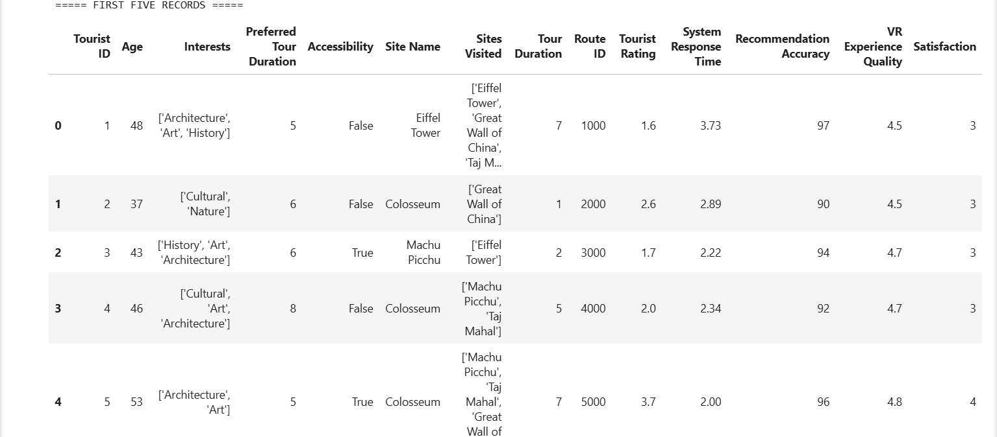
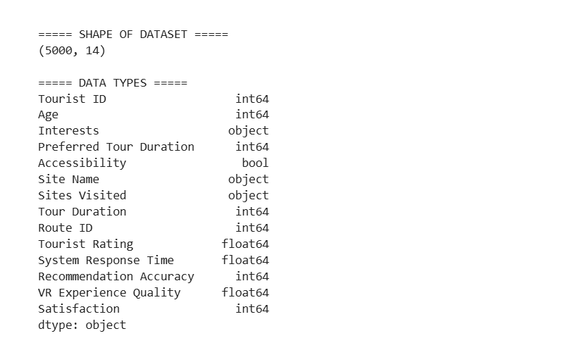
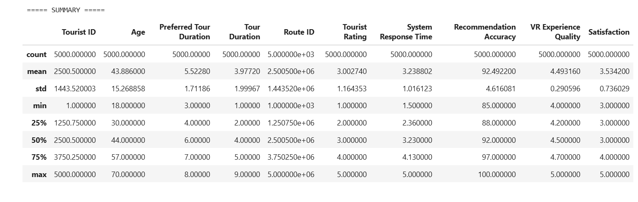
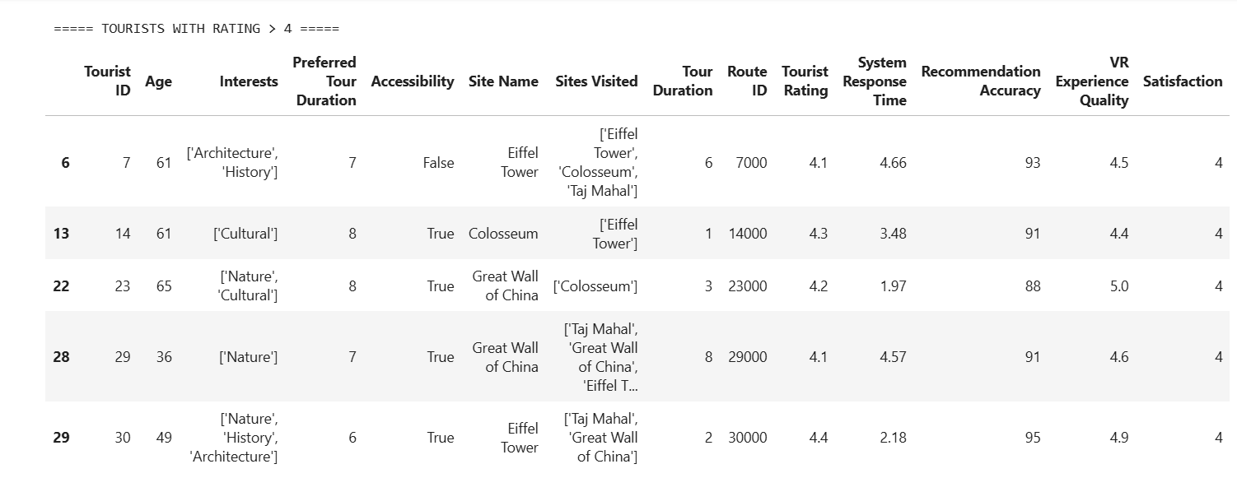

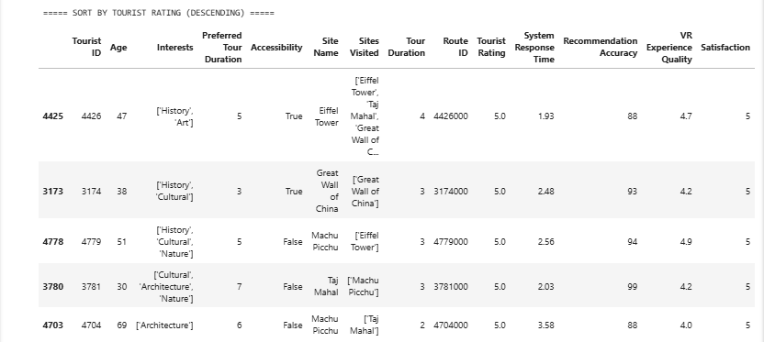

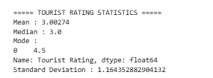
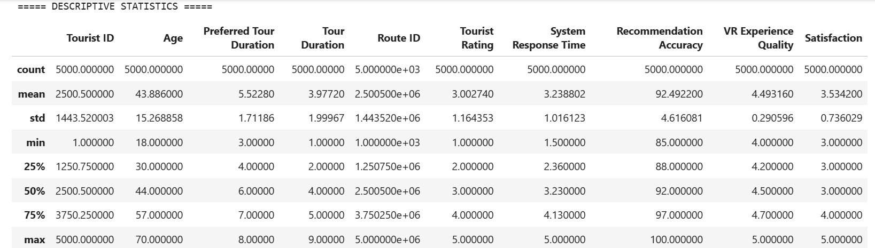
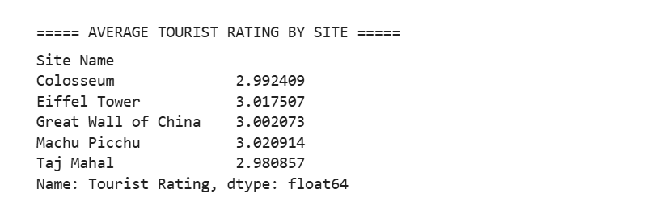

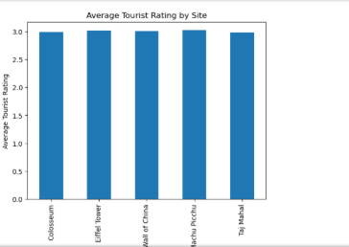

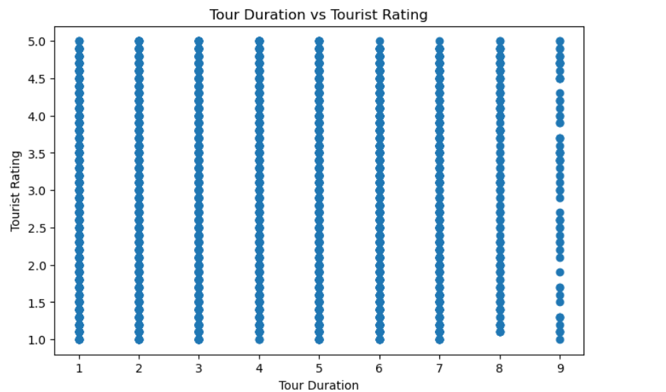

RESULT
Thus, data inspection, filtering, sorting, descriptive statistical analysis, grouping, aggregation, and correlation analysis were successfully performed using Pandas. The analytical results were visualized and interpreted successfully.

